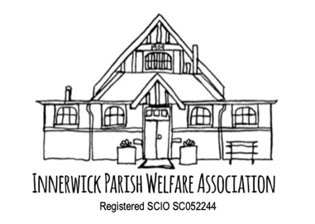 | Innerwick Village Hall  Booking Form

Title of Event Entrance Fee
Event Organiser Email Mobile
Event Treasurer (if different) Email Mobile
Other Volunteers involved
Event Day/Date(s) Times

Event Description (for Facebook and Newsletter) Brief description of activities involved, to include details of any special clothing or equipment requirements, targeted age group and level of beginners/intermediate/advanced/open to all experience. Make sure you give details of your booking arrangements and contact details.

If relevant, add any biographical details re experience etc.

Resources : Do you need:

Sound/video system Screen Storage Facilities Kitchen

Other
Agreement  I/we have completed a Risk Assessment for this Event.  I/my organisation has Public Liability Insurance for this event.  I/we have safeguarding strategies in place.  I confirm our electrical equipment has been PAT tested.  I confirm compliance with Food Safety / Health and Hygiene regulations.  I confirm that our equipment/resources /practices meet H&S standards.  I confirm that we hold the required music/alcohol licences for this event. |  | Yes ❑ No ❑  Yes ❑ No ❑  Yes ❑ No ❑ N/A ❑  Yes ❑ No ❑ N/A ❑  Yes ❑ No ❑ N/A ❑  Yes ❑ No ❑ N/A ❑  Yes ❑ No ❑ N/A ❑
Declaration
□I/we have read the User Responsibilities as outlined in the User Handbook and agree to abide by them.
□I/we are happy to be included in Publicity materials relating to IPWA activities
□I/we undertake to comply with the Covid-19 requirements operating at that time.
□I/we undertake to take all recycling materials home with us. (General waste goes in big bin outside.)
Signed | Date:
Please return this form to bookings@ipwa.scot - your booking will be confirmed (pending availability check) and invoiced.

